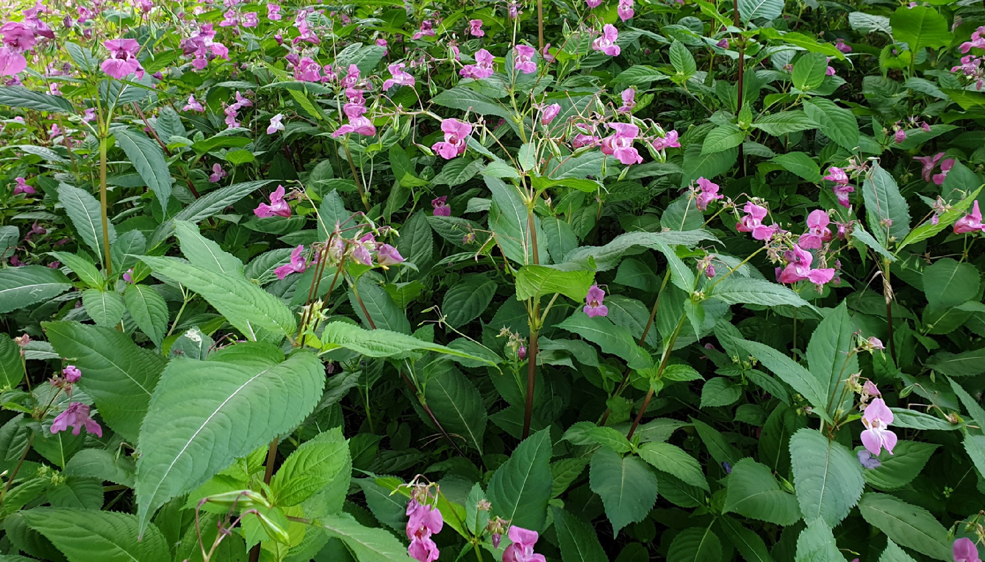

**Warcop**

**to Sandford riverside footpath**

**Sunday 27th July, 10.30 am – 2.30 pm**

**Start point at the stile.**

**w3w ///digitally.mystery.betraying**

**Very limited parking, please walk down or meet at**

**Warcop parish hall at 10.15am to lift share.**



**T**

**h**

**e**

**... pulling out invasive, non-native Himalayan balsam to**

**protect riverbanks and native flowers! It’s easy, fun and**

**a good workout! Join in a Big Balsam Bash near you:**

**e**

**d**

**e**

**n**

**r**

**i**

**v**

**e**

**r**

**s**

**t**

**r**

**u**

**s**

**t**

**.**

**o**

**r**

**g**

**.**

**u**

**k**

**/**

**t**

**h**

**i**

**n**

**g**

**s**

**-**

**t**

**o**

**-**

**d**

**o**

**2025**

**Wear old clothes -**

**long-sleeve tops, trousers,**

**waterproofs and gardening or work gloves**

**(**

**we can lend you some!), wellies/sturdy shoes.**

**Bring drinks and packed lunch if staying all day.**

**All ages welcome, under 18s must be accompanied**

**by a responsible adult.**