# **Community Emergency Plan Summary**

**Warcop Parish Council**

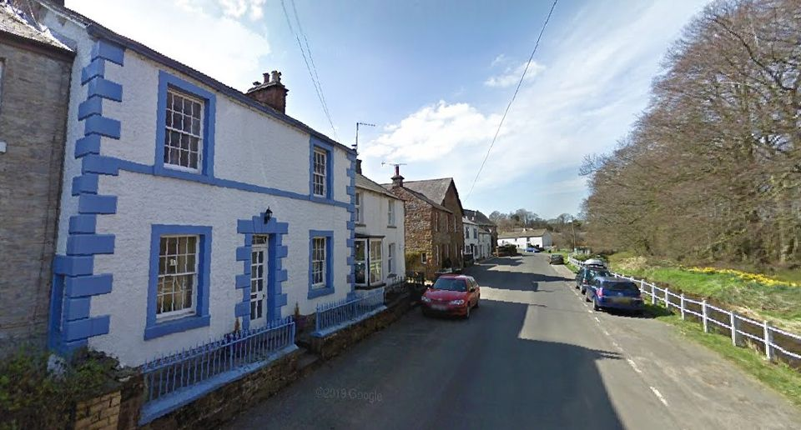

1. **COMMUNITY RESPONSE GROUP (CRG)**

|  |  |  |
| --- | --- | --- |
| **Name** | **Tel:** | **Email:** |
| Andrew Parkinson*  Chair of Parish Council | 07595 835275 | andypksn@outlook.com |
| Nikki McDowall, Parish Councillor | 07739 3120238 | nikkimcdowall@outlook.com |
| Gordon Deighton, Parish Councillor | 07970 982101 | g.h.deighton@outlook.com |
| Albert Clee, Parish Councillor | 07387 796156 | Albert1951@btinternet.com |

* Indicates the person who will coordinate the community response and be the point of contact for local authorities / emergency services. If unavailable, the next person listed will do this.

Copies of the full Emergency Plan are restricted and will be held by the CRG members. An electroniccopy of the plan will also be made accessible to local authorities and emergency services via Resilience Direct.

Date Adopted: 16/05/2024

Last Reviewed: 10/7/2025

Review Due: July 2028

**2. PURPOSE**

**Definition of an emergency:**

An emergency / major incident is any event or circumstance (happening with or without warning) that causes or threatens death or injury, disruption to the community, or damage to property or to the environment on such a scale that the effect cannot be dealt with as part of the emergency services, local authorities and other organisations normal day-to-day activities.

**Aim of the Community Emergency Plan:**

To increase resilience within the local community before, during and after emergencies, and to link into the county and district councils’, and emergency services’ emergency response structures, where appropriate. This Plan documents how Warcop Parishwould respond in an emergency situation.

e.g., while awaiting the assistance of statutory authorities / emergency services, or in support of them.

**It is not the role of the community to take on the responsibilities of these agencies e.g. to save life, to take any risks to themselves or to cope for long hours without agencies’ help and support.**

The plan may also be used when there is no emergency, but when the group feels it would be beneficial to do so. E.g. when snow or icy conditions cause problems for some residents trying to get out to shop for food and collect prescriptions.

**Objectives:**

* + - Identify possible emergencies, impacts on the community, and relevant actions.
    - Identify communications and resources in the community available to assist in an emergency
    - Consider vulnerable people / groups in the community who may need additional support.
    - Provide contact details for the Community Response Group (CRG), key community resources, the Emergency Services, and County and District Councils.
    - Risk assess the proposed community response.

**3. ACTIVATION OF THE PLAN**

This plan will be activated by the Community Response Group (CRG). The group will meet in person or communicate remotely to assess the situation, ring Emergency Services and consult with the District Council if necessary. The CRG will then put all or part of the Plan into effect as appropriate.

The Plan may be activated when:

* + - An emergency has occurred
    - Warnings are received prior to an anticipated emergency
    - Emergency services request support or are not able to attend immediately.
    - No emergency / warning has occurred but it is felt a community response would be of benefit, particularly for more vulnerable residents e.g. prolonged cold snap and icy conditions.

Volunteers may be put on stand-by prior to full activation of the plan, depending on the situation.

**4. PLACE OF SAFETY:**

District councils are responsible for setting up Emergency Assistance Centres (EAC) during an emergency, which are run by council staff and may be used for a range of purposes, depending on the situation. Many schools, churches and community buildings are designated EACs.

However, it may be necessary to set up a temporary community-run Place of Safety e.g. for stranded travellers or people evacuated from their homes. In our community, the place of safety will be:

*Warcop Parish Hall*

The CRG will contact the key-holder and other volunteers, as necessary.

**5. COMMUNICATION AND CONTACTS**

|  |  |  |
| --- | --- | --- |
| **Organisation** | **Phone** | **Website / Twitter** |
| **Emergency Services** | **999** |  |
| **Police:**  (non-emergency) | 101 | [www.cumbria.police.uk](http://www.cumbria.police.uk)  @Cumbriapolice |
| **Parish Council** | See above |  |
| **Westmorland & Furness Council:** | 0300 373 3300 | <https://www.westmorlandandfurness.gov.uk/your-council/about-your-council/contact-us> |
| If you have concerns about an adult in Barrow, Eden or South Lakeland contact Westmorland and Furness Council | 0300 373 3301 | <https://legacy.westmorlandandfurness.gov.uk/healthsocialcare/ccc/contact.asp>  <https://www.cumbriasab.org.uk/> |
| **Westmorland and Furness Council – Highways:** | 0300 373 3306 (option 5) | <https://www.westmorlandandfurness.gov.uk/parking-streets-and-transport/streets-roads-and-pavements/road-maintenance-closures-and-improvements/report-problem-street-or-road> |
| **NHS:** |  | [www.nhs.uk](http://www.nhs.uk)  @NHSEngland |
| **Environment Agency / Floodline:** | 0345 988 1188 | [flood-warning-information.service.gov.uk](http://www.flood-warning-information.service.gov.uk)  @EnvAgencyNW |
| **Met Office:**  (forecast & weather warnings) |  | [www.metoffice.gov.uk](http://www.metoffice.gov.uk)  @metoffice |
| **Electricity North West:**  (electricity) | 105 (power cut)  0800 195 4141 | [www.enwl.co.uk](http://www.enwl.co.uk)  @electricityNW |
| **National Grid:**  (gas / carbon monoxide) | **0800 111 999** | [www.nationalgridgas.com/safety-and-emergencies](http://www.nationalgridgas.com/safety-and-emergencies)  @nationalgriduk |
| **United Utilities:**  (water incl. sewerage flooding) | 0345 672 3723 | [www.unitedutilities.com/emergencies](http://www.unitedutilities.com/emergencies)  @unitedutilities |
| **Local social media platforms** | | |
| **Facebook:** | Warcop Facebook page | |
| **Website:** | www.warcop-pc.org.uk | |

**6. PLAN REVIEW AND UPDATE**

In order to keep details up to date, this plan, plus any supplementary documents, volunteer contact lists, risk assessment etc., will be reviewed and updated as needed. The plan will be reviewed annually, by Warcop Parish Counciland the date recorded on the front page.

Following review, an updated electronic copy of the unrestricted plan will be made available to local authorities and emergency services via Resilience Direct.

During an emergency, volunteers will keep a record of actions taken. These will be entered into a central log, kept by the CRG, so that they can be evaluated, and the plan altered if necessary. Information can be entered at the time, or directly after the emergency.